# Sanlam

Sanlam is the largest non-banking financial services group on the African continent, with a leading niche presence in Asia. We are market leaders in life insurance, general insurance, and investment management in our home market of South Africa and countries across Africa. With a history spanning over a century, we have a trusted brand, leading industry expertise, and high levels of client loyalty.

Sanlam is a purpose-led financial services group headquartered in South Africa, operating across a number of selected global markets. We have been creating value for stakeholders since 1918 – for more than 100 years – with all our efforts centred on helping our clients live with confidence.

## 2023 Key Figures

**31 countries**

* We operate in 31 counties across Africa, Asia and the UK , and are present in eight of the top 10 largest economies in Africa.

**113 748 employees**

* We attract the best people in the market, which creates a diverse and skilled workforce.

**R1 trillion**

* Leading scale business, driving efficiencies and shareholder outcomes with R1.3 trillion in assets under management and administration across our business.

**69 million**

* We touch the lives of over 69 million clients across Africa and Asia.

**Inclusion**

* Insurance footprint in Africa. With our partner, MTN Group, Africa’s largest mobile operator, we provide access to a full range of insurance services.

**Level 1**

* Sanlam retained its status as a level 1 B-BBEE contributor in South Africa – the highest level a company can achieve

## Global Footprint

**SanlamAllianz** covers 27 countries in Africa across various lines of business.

* Angola
* Benin
* Botswana
* Burkina Faso
* Burundi
* Cameroon
* Côte d'Ivoire
* Egypt
* Gabon
* Ghana
* Kenya
* Madagascar
* Malawi
* Mali
* Mauritius
* Morocco
* Mozambique
* Namibia
* Niger
* Nigeria
* Rwanda
* Senegal
* Tanzania
* Togo
* Uganda
* Zambia
* Zimbabwe

## Values

* Care
* Collaboration
* Innovation
* Integrity

## Business Clusters of Sanlam

1. Sanlam Life and Savings (SLS)
   1. Made up of **Retail mass (SRM), retail affluent (SRA) and Sanlam corporate (SC)**
   2. **SLS** provides financial planning and advice, insurance and investment, as well as healthcare products to retail and institutional clients in South Africa
   3. The cluster relies on its advice, distribution capabilities, digital tools, and channels to provide comprehensive solutions through an ecosystem that also rewards loyalty and encourages long-term thinking. Focusing on client-centricity and holistic solutions, and through strategic partnerships and continuous innovation, SLS is able to increase its reach and scale to meet more of its clients’ needs.
2. Sanlam Emerging Markets (SEM)
   1. Made up of **SanlamAllianz, Namibia and Asia**
   2. SEM provides a wide range of products covering life and general insurance, healthcare, reinsurance, asset management and retail credit products to commercial, corporate, institutional and retail clients, including the underserved and underbanked
   3. **SEM** leverages its local partnerships and shared-value model to build successful businesses and contribute to community upliftment and economic development in the countries where it operates. By operating in geographies that have poor access to financial service products, SEM promotes financial inclusion. The cluster is well positioned to capture growth in Africa and Asia through its extensive footprint, diverse distribution platform and product offering, SEM gives millions of people access to a growing range of relevant financial services solutions
3. **Sanlam Investment Group (SIG)**
   1. SA investment management, Wealth management, international and SanFin
   2. SIG offers a broad range of investment management, credit and risk management expertise to retail and institutional clients in Africa and the UK.
   3. SIG supports Sanlam’s purpose through its superior solutions, extensive product range and strong track record of investment performance. The cluster’s impact-investing initiatives contribute to a better future for the societies where it operates. Sanlam Investments, one of South Africa’s largest black-owned asset managers, is committed to transformation while supporting access to cost-effective financial solutions and a diversity of asset classes.
4. Santam
   1. Santam is a leading South African general insurer with an international presence in selected territories.
   2. Santam offers a range of policies against property damage, motor accidents, loss of income, crop losses and catastrophe loss. Santam’s primary function is to displace risk so that clients’ insured losses are paid out of invested premiums
   3. Largest short-term insurer in South Africa, with a diverse product offering
5. Sanlam Fintech (SFT)
   1. Sanlam Fintech drives financial services through non-intermediated digitalisation, innovation and financial inclusion utilising technology.
   2. SFT offers a range of digital products including life and general insurance, credit and investments and rewards offerings.
   3. Leveraging digital capabilities and platforms for greater client reach is achieved through cost-efficient models, furthering financial inclusion.
6. Group Office
   1. Supports the Group Chief Executive and clusters, mainly providing strategic direction and co-ordination, encouraging collaboration and identifying synergies, performance monitoring, reporting and assurance, allocating capital, and rendering centralised support services to businesses across the group

# Sanlam Life and Savings

Sanlam Life and Savings (SLS) offers retail and corporate life insurance and investment products in South Africa. The cluster provides clients with a comprehensive range of appropriate and competitive financial solutions, designed to facilitate long-term wealth creation and protection. SLS has strong market positions in its businesses and is well diversified across product and segment. The cluster is well positioned to further entrench its market presence to build a fortress position in South Africa.

## Key Strengths

SLS uses its advice and distribution capabilities to serve client needs from simple to complex insurance and savings products. SLS embraces partnerships and innovation to better meet client needs.

## Key Financial Solutions

* Funeral cover business and related services.
* Risk underwriting products and recurring premium savings solutions.
* Single premium life and linked investsment savings plan (LISP) solutions.
* Employee benefits and health solutions

# SA Retail Mass

SA Retail Mass (SRM) is part of the Sanlam Life and Savings cluster within the Sanlam Group. We focus on retail products and group schemes in the South African entry-level and emerging middle markets.

## What we do

We aim to understand the unique requirements of our clients and offer a wide range of simple and affordable financial solutions that cover their specific needs, such as funeral insurance, savings for education, life cover and personal accident plans.

**Our aim is to introduce relevant solutions to our market through:**

* Making informed choices at every stage of life.
* Making a secure future possible.
* Helping customers prepare for the future, and life's surprises along the way.
* 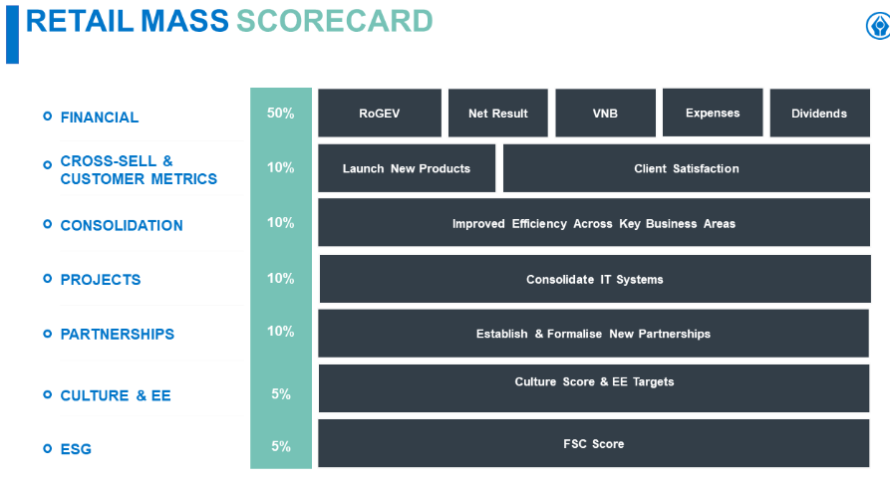Giving confidence in what the future holds - empowering people to live with confidence.

## Products for SRM

**Sanlam My Choice Enhanced Funeral Plans**

The Sanlam My Choice Enhanced Funeral Plans give you more cover and more choice at an affordable premium. You can choose the features and level of cover you and your family need and can afford.

**Sanlam All In One**

The Sanlam All In One Plan covers all your life and funeral needs in one policy, with one premium, and no medicals or blood tests are required. You only need One Plan. If you currently have more than one, you can combine your existing cover without having to pay double premiums.

**Sanlam Value Funeral Plans**

The Sanlam Funeral Plan allows you to choose a funeral range that you and your family need and can afford. There may not be a waiting period on the plan if you had previous funeral cover for yourself and your loved ones.

**Sanlam Immediate Life Cover**

Sanlam Immediate Life Cover pays up to R2 000 000 to your beneficiaries on your death or if you suffer a disability event resulting in a permanent physical impairment. Cover is available to anyone between 18 and 60 years old, and no medicals or blood tests are required.

**Sanlam My Choice Income Plan**

In the event that you pass away or if you become physically impaired, the Sanlam My Choice Income Plans can help take care of some of your family's monthly costs if these unfortunate events happen. Anyone between the ages of 18 and 64 can take up the My Choice Income Plans.

The My Choice Income Range offers you two options to choose from:

* Sanlam Income Plan – Death
* Sanlam Income Plan – Death and Physical Impairment

**Sanlam My Choice Investment Plans**

The Sanlam My Choice Investment Plan allows you to choose an investment plan for those things you really want. Choose from:

* Sanlam Invest to Graduate
* Sanlam Invest to Own
* Sanlam Invest to Dream

**Sanlam New Life Retirement Annuity**

After years of hard work, you deserve to live comfortably when you retire. With the Sanlam Retirement Annuity, you can put away an affordable amount of money to help you retire with peace of mind.

## Departments in SRM

* Actuarial and Product Development
* Distribution
* Finance
* Human Capital
* Information Technology
* Legal, Compliance and Complaints
* Operations
* Strategy Implementation
* Strategy, Marketing and Client

# Corporate

Sanlam Corporate (SC) is a leading provider of financial advice, insurance, retirement solutions, investments and EFT services to corporates across South Africa.

Sanlam Corporate (SC) empowers your organisation and its people to be financially confident about the future.

SC aims to partner with corporates/employers and their employees in delivering effective Employee Benefits, Investment and Health Care Solutions, to empower financial confidence, security and growth. We pioneer inclusive financial confidence for businesses and their people. As an employee benefits member, Sanlam is committed to empowering your financial confidence, security, and prosperity.

SC offers:

1. Group Risk Benefits
2. Investment Capabilities
3. Retirement
4. Health Solutions

# Sanlam Investments

Sanlam Investments (SI) has a simple mission: to unlock the opportunities for our clients that are difficult to find.

We manage over R400 billion in assets under management and offer a wide range of investment capabilities across active management, alternative investments, index tracking, multi-management and international investments.

Sanlam Investments offers a comprehensive range of personal finance products. Our unit trusts allow you to invest both locally and internationally and no matter what your risk tolerance or investment goals are, we have a fund to suit your unique requirements.

1. Core Funds
2. Unit trusts
   1. Sanlam unit trusts give you access to some of South Africa’s top investment managers, so you don’t have to navigate the share markets alone. Our comprehensive range of personal finance products offers a multitude of risk and return options, with a solution for every risk appetite and investment horizon.
   2. From R500 a month you can enjoy access to a wide range of funds, offering you both local and international investment options. With no lock-in period, unit trusts give you plenty of choice and flexibility. Invest in one or more of our unit trusts today, and start saving towards your financial goals.
   3. A unit trust gives easy, cost-effective access to assets such as shares, listed property and bonds, which are not usually available to direct investors with relatively smaller amounts to invest. The fund manager is responsible for diversifying your investment to protect it from being too exposed to a potential fall of a single asset.
3. Tax-free Investments
4. Hedge Funds

# Sanlam Group Technology

Using the means in which the Sanlam Group has defined their purpose, **Sanlam Group Technology (**SGT) has defined their purpose within this context, which forms a basis for the SGT strategy.

**Mission**: To accelerate and enable the fortress SA and Emerging Markets strategy through the co-creation and delivery of capabilities and enabling technology solutions.

**Strategy**: To unleash differentiating capabilities and enabling technology closest to point of business value, accelerating the digital delivery model, and the supporting architecture , tools and methods with our business customers that enables them to succeed.

**Vision**: To distinguish ourselves as a leading technology and transformation partner, core to widespread enterprise value, digital enablement and innovative use of technology.

**Purpose**: We use our passion and expertise to accelerate and future fit the Sanlam business to empower generations to be financially confident, secure and prosperous.

Theo Mabaso is the CIO Group Technology for SGT. Theo was appointed Group CIO for Sanlam in 2020. He believes that being a CIO is not binary, and it is important to understand the value of tech, people, and change.

# Glacier

We help you create and preserve your wealth through a comprehensive collection of investment solutions.

Glacier by Sanlam brings together leading experts and respected financial services companies to meet clients’ investment needs. We deliver focused financial services through specialist teams, and pride ourselves on being a chosen partner of acclaimed financial intermediaries through our superior solutions and our quality service.

Our collection of investment solutions has been designed to span a lifetime, and to fulfil the needs each life stage may bring – whether you are focusing on the creation or the preservation of your wealth.

Our offering encompasses local investments, including fixed-term investments and investments with guarantees, international investments, retirement saving solutions and retirement income solutions.

While each solution has its own distinct purpose, they all share the world-class quality and commitment that have come to distinguish Glacier.

Glacier Offers:

1. Investments
2. Retirement
3. Financial Planning

## Values

The way we do business is as important as the solutions we provide.

We are very proud of the exceptional relationships we have with our clients, our financial planners and our people. More than anything we believe this relationship-based approach sets us apart from our competitors.

* We foster a high-performance, goal-driven and energetic culture and a strong service ethic
* We believe that it is our obligation to provide world-leading service based on honesty, integrity and respect
* We pride ourselves on our superior products and solutions and high quality service, while we benchmark ourselves against international standards and continually seek innovative ways to improve our offering
* We believe that partnership, teamwork and leadership at all levels ensure sustainable success
* Our overriding strategy at all times is about leadership through client relationships